**Javascript/Jquery Test:**

1. **What is the difference between Javascript & Jquery?**

Javascript is one of the language that is used for the development of the browser for interaction with the user. With javascript we can create functions, events.

Jquery is a library of javascript that simplifies the event of multiple lines of code into single line. It also can perform action specific events where the data communication without reloading the entire page

1. **How to get element by Id, Class, Tag Name, Attribut**e?
2. **How can you add Jquery library into your project?**

Inside the head tag add the below script tag and it will be imported from the jquery library

<script src="https://ajax.googleapis.com/ajax/libs/jquery/3.5.1/jquery.min.js"></script>

1. **What is the different between the .text() and .html() method in Jquery or innerText and innerHTML in Javascript?**Inner HTML – it will use the tag name or id or class to and it will execute the function in same line

Inner text- it will printed in separate line and execute the function

1. **I have element as**

**<span class=”testElement”><strong>This is the test element</span>**

**How do you get the element text and html inside the span element?**

1. **What is the use of document.ready(function(){});**

The Ready event occurs when the DOM elements are loaded. It specifies that the document is ready and can be used as a function for events.

1. **What is event handler in javascript/jquery? Provide some example for .on event handler**

Event methods trigger an action or attach a function to the event handler for the selected elements. For example blur(), click(), change().

1. **Create a button name as Test. Show some message on click of that button**
2. **How do you change the content of the element? Please write some example**

The content of the element can be changed using Inner HTML. We can use the above example for tag name id or class

1. **What is the difference between == and === operator?**

It is a type of operator in javascript.

== compares the value of same variable. For ex. If it’s a string it compares the value in string

=== compared the value of the same variable and checks the value type also.

1. **Create function name called printMessage. It should get 3 parameters called as a, b, type.**

**If I call the method as printMessage(5, 4. “Add”), it should return 9**

**If I call the method as printMessage(5, 4. “Sub”), it should return 1**

**If I call the method as printMessage(5, 4. “Multiple”), it should return 20**

1. **How to add the class to the element/remove class from the element? Provide some example**
2. **How to remove the element? Provide some example?**
3. **What is the difference between button type submit and button type button in form?**

Button type submit by default is a submit the form meaning that the form has been completed.

Button type button is simply a button that cannot submit the form

1. **What is the difference between below 3 type of events? And provide some example**

**Onclick event in element**

this event defines the function on click of the button what type of function has to be executed

**$(“.className”).click(function(){ do some task});**

This event get the element by class name . and on click of the button it will perform the function which we define inside function.

**$(document).on(“.className”, “click”, function(){ do some task});**

1. **Add select name html dropdown with options are, “mani”, “ramu”, “raja”, “Arun”. Add change event to it. On change of dropdown values, show the selected value in alert message.**
2. **How to get the value of input textbox, checkbox and radio button. Please provide some example**
3. **Create an empty array and push the values from 20 to 50 and print the array values.**
4. **Remove the even numbers from array between 20 to 50 and print the array values**

**CSS test:**

1. **What is the difference between the Id and Class? Please provide some example for it**

Id denotes with # and class denotes with .

For example **id=”demo” class=”demo”** can be written as

#demo{} and .demo{}

1. **How to import bootstrap library into your project?**

There are two ways by importing through a CDN and website.

Paste the code inside the head tag

<link rel="stylesheet" href="https://maxcdn.bootstrapcdn.com/bootstrap/4.5.2/css/bootstrap.min.css">

1. **What is the use of bootstrap? Please provide some example**

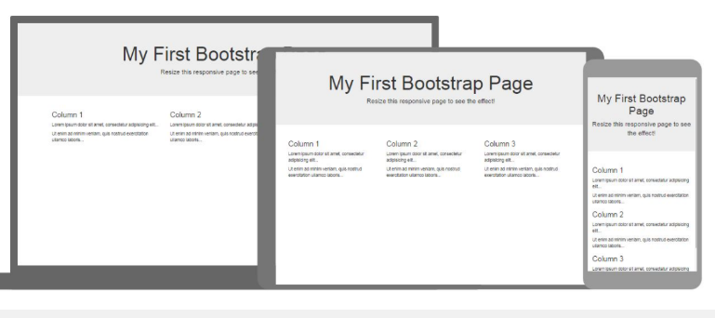

Bootstrap is a framework to help you design websites faster and easier. It includes HTML and CSS based design templates for typography, forms, buttons, tables, navigation, modals, image carousels, etc..Here are some additional reasons to use Bootstrap: Bootstrap's responsive CSS adjusts to phones, tablets, and desktops.

1. **What is the use of classes called row, col-lg-* col-md-* col-sm-* col-xs-*?**

There are mainly five class in grid system which are listed below:

* .col- Extra Small ( < 576 px )
* .col-sm- Small ( >= 576 px )
* .col-md- Medium ( >= 768 px )
* .col-lg- Large ( >= 992 px )
* .col-xl- Extra Large ( >= 1200 px )

It provides 12 columns per row which is made available in the Column class. So, you can control the width of column using specifying numbers in .col-*, where * means the width of the column in numbers. For example we can write col-lg-3, it will divided

1. **What is the different between the inline css, style attr css(Internal css) and external css?**

Inline CSS allows you to apply a unique style to one HTML element at a time. We can assign CSS to a specific HTML element by using the style attribute with any CSS properties defined within it.

The style attribute specifies an inline style for an element. The style attribute will override any style set globally, e.g. styles specified in the <style> tag or in an external style sheet.

With an external style sheet, we can change the look of an entire website by changing just one file. Each HTML page must include a reference to the external style sheet file inside the <link> element, inside the head section.

1. **What is the use of media queries? Provide some example**

Media queries are used as the alternate stylesheet and it changes the color of the background based upon the width. There are 4 media types all, print, screen, speech. Media queries uses @media and width to be defined.

@media screen and (max-width: 992px) {  
  body {  
    background-color: blue;  
  }  
}

1. **What is the use of box model? What is padding, margin, border. Provide some example**

The CSS box model is essentially a box that wraps around every HTML element. It consists of: margins, borders, padding, and the actual content.

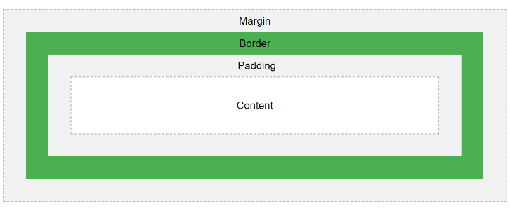

1. **What is the use of display style in css? Provide some example**

The display property specifies the display behavior (the type of rendering box) of an element. In HTML, the default display property value is taken from the HTML specifications or from the browser/user default style sheet. The default value in XML is inline, including SVG elements.

For example we have inline, block , flex etc…

1. **What is the use of Position style in css? Provide some example**

The Position property specifies the type of positioning method used for an element.

There are different position values static, relative, absolute, sticky.